Program MATLAB:
%% ==============================
%% PARAMETER SISTEM
%% ==============================
M = 1; % massa cart (kg)
m = 0.6; % massa pendulum (kg)
b = 0.1; % gesekan (Ns/m)
l = 0.4; % panjang (m)
I = 0.006; % inersia (kg.m^2)
g = 9.8; % gravitasi (m/s^2)

p = I*(M+m) + M*m*l^2;

%% ==============================
%% 1. FUNGSI TRANSFER
%% ==============================
num = [m*l 0];

den = [p ...
b*(I+m*l^2) ...
-(m*g*l*(M+m)) ...
-b*m*g*l];

TF = tf(num, den);

disp('=== FUNGSI TRANSFER ===');
TF
=== FUNGSI TRANSFER ===
TF =
0.24 s
------------------------------------------
0.1056 s^3 + 0.0102 s^2 - 3.763 s - 0.2352
Continuous-time transfer function.
Model Properties

%% ==============================
%% 2. STATE-SPACE
%% ==============================
A = [0 1 0 0;
0 -(I+m*l^2)*b/p (m^2*g*l^2)/p 0;
0 0 0 1;
0 -(m*l*b)/p m*g*l*(M+m)/p 0];

B = [0;
(I+m*l^2)/p;
0;
m*l/p];

C = [1 0 0 0;
0 0 1 0];

D = [0;0];

sys_ss = ss(A,B,C,D);

disp('=== STATE SPACE ===');
sys_ss
=== STATE SPACE ===
sys_ss =
A =
x1 x2 x3 x4
x1 0 1 0 0
x2 0 -0.09659 5.345 0
x3 0 0 0 1
x4 0 -0.2273 35.64 0
B =
u1
x1 0
x2 0.9659
x3 0
x4 2.273
C =
x1 x2 x3 x4
y1 1 0 0 0
y2 0 0 1 0
D =
u1
y1 0
y2 0
Continuous-time state-space model.
Model Properties

%% ==============================
%% 3. KONVERSI TF ke STATE SPACE
%% ==============================
[num_tf, den_tf] = tfdata(TF,'v');
[A2,B2,C2,D2] = tf2ss(num_tf, den_tf);

disp('=== HASIL KONVERSI TF ke SS ===');
A2, B2, C2, D2
=== HASIL KONVERSI TF ke SS ===
A2 =
-0.0966 35.6364 2.2273
1.0000 0 0
0 1.0000 0
B2 =
1
0
0
C2 =
0 2.2727 0
D2 =
0

%% ==============================
%% 4. IMPULSE RESPONSE
%% ==============================
figure;
impulse(sys_ss);
title('Open Loop Impulse Response');
grid on;
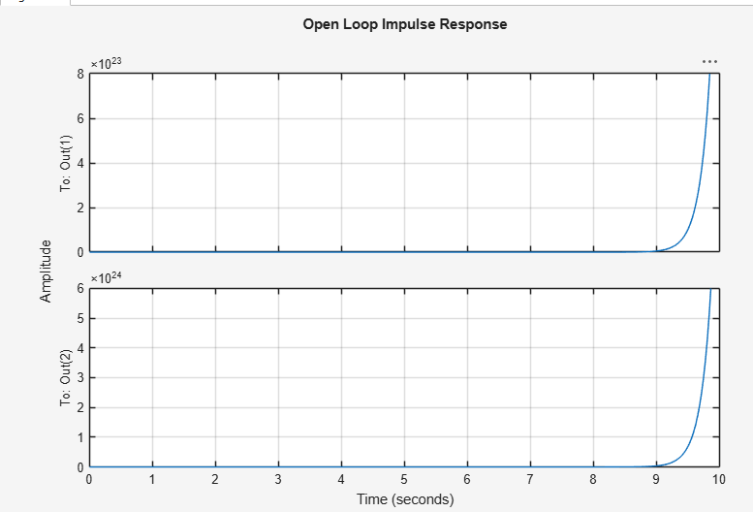
%% ==============================
%% 5. POLE-ZERO MAP
%% ==============================
figure;
pzmap(sys_ss);
title('Pole-Zero Map');
grid on;

poles = pole(sys_ss);
zeros = zero(sys_ss);

disp('=== POLES ===');
disp(poles);

disp('=== ZEROS ===');
disp(zeros);
Warning: Use TZERO to compute the transmission zeros of a SISO or MIMO model.
> In DynamicSystem/zero (line 28)
=== POLES ===
0
-0.0625
-5.9869
5.9528
=== ZEROS ===
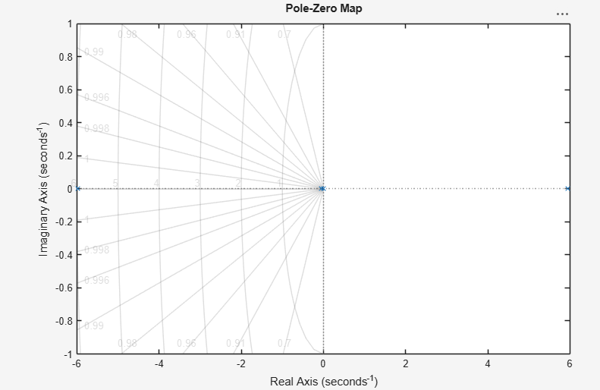
%% ==============================
%% 6. STEP RESPONSE
%% ==============================
figure;
step(sys_ss);
title('Open Loop Step Response');
grid on;
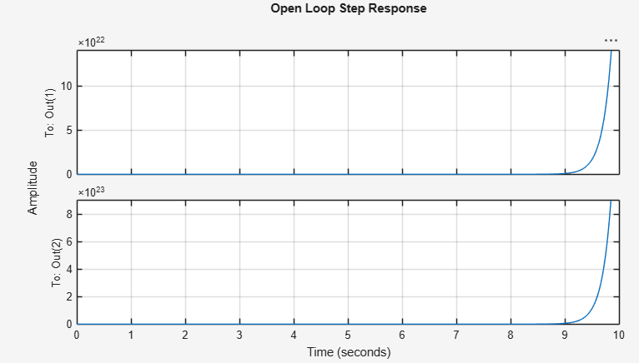
> %% ==============================
%% 7. SETTLING TIME
%% ==============================
info = stepinfo(sys_ss);

if isempty(info.SettlingTime) || isnan(info.SettlingTime) || isinf(info.SettlingTime)
disp('Settling Time = Tidak ada (Sistem Tidak Stabil)');
else
fprintf('Settling Time = %.4f detik\n', info.SettlingTime);
end
Warning: Simulation did not reach steady state. Please specify YFINAL if this system is stable and
eventually settles.
> In DynamicSystem/stepinfo>localSTEPINFO (line 87)
In DynamicSystem/stepinfo (line 59)
Error using isempty
Too many input arguments.

%% ==============================
%% 8. KESIMPULAN
%% ==============================
disp('KESIMPULAN:');
disp('Sistem inverted pendulum tidak stabil pada open-loop karena terdapat pole di sisi kanan.');
disp('Respon impulse dan step menunjukkan sistem divergen.');
disp('Settling time tidak terdefinisi karena sistem tidak mencapai steady state.');

KESIMPULAN:
Sistem inverted pendulum tidak stabil pada open-loop karena terdapat pole di sisi kanan.
Respon impulse dan step menunjukkan sistem divergen.
Settling time tidak terdefinisi karena sistem tidak mencapai steady state.

